1.Convert centegrade to farenheit ( f= 9/5*c+32)

def compound_interest(principle, rate, time):

CI = principle * (pow((1 + rate / 100), time))

print("Compound interest is", CI)

p=int(input("enter p value: "))

n=int(input("enter n value: "))

r=float(input("enter r value: "))

compound_interest(p, r, n)

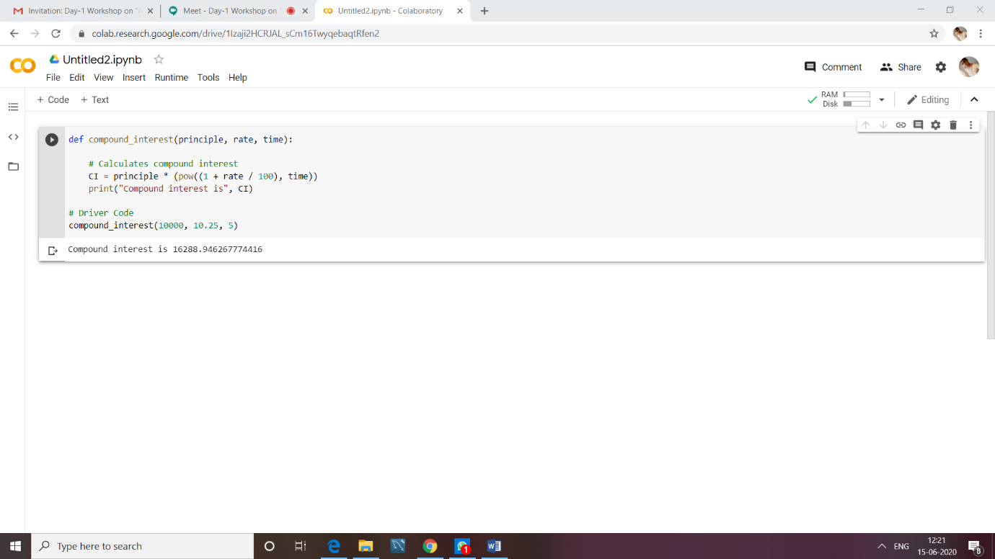

2.Find the greater of two nos

celsius = float(input("Enter temperature in celsius: "))

fahrenheit = (celsius * 9/5) + 32

print('%.2f Celsius is: %0.2f Fahrenheit' %(celsius, fahrenheit))

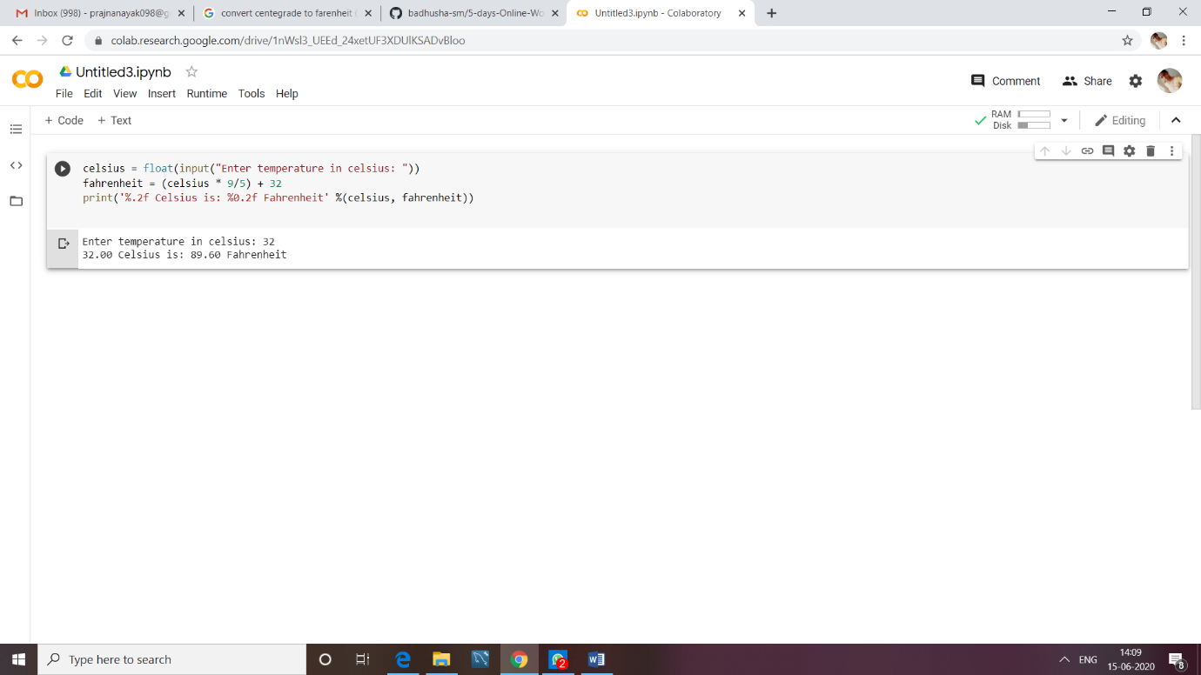

3.Write a program for finding surface areas of cylinder and cone (2*PI*r*r*h, 1/3*PI*r*r*h) using function.

import math

def Cylinder(r,h):

return 2*math.pi*r*r*h

def cone(r,h):

return (1/3)*math.pi*r*r*h

r=int(input("enter r value : "))

h=int(input("enter h value"))

print("surface area of cylinder is : %.2f"%Cylinder(r,h))

print("surface area of cone is : %.2f "%cone(r,h))

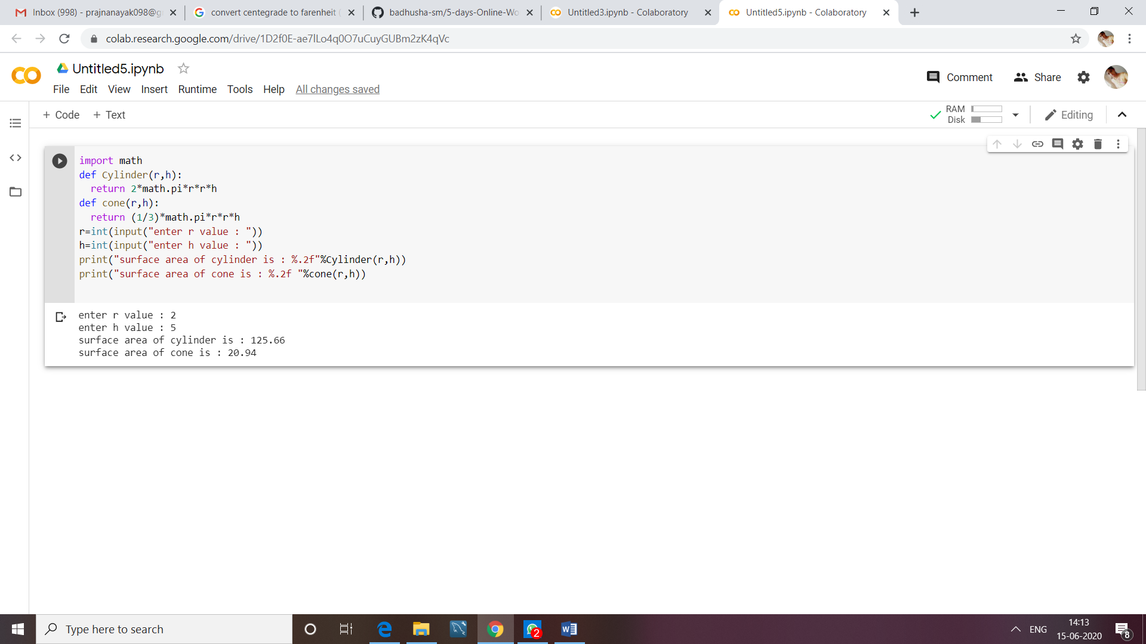

4.Find the greatest of four nos ( using ‘**and’** operator) using function.

a=int(input("enter 1st num: "))

b=int(input("enter 2nd num: "))

c=int(input("enter 3rd num: "))

d=int(input("enter 4th num: "))

print("greater num is : ")

if(a>b and a>c and a>d):

print(a)

elif(b>c and b>d):

print(b)

elif(c>d):

print(c)

else:

print(d)

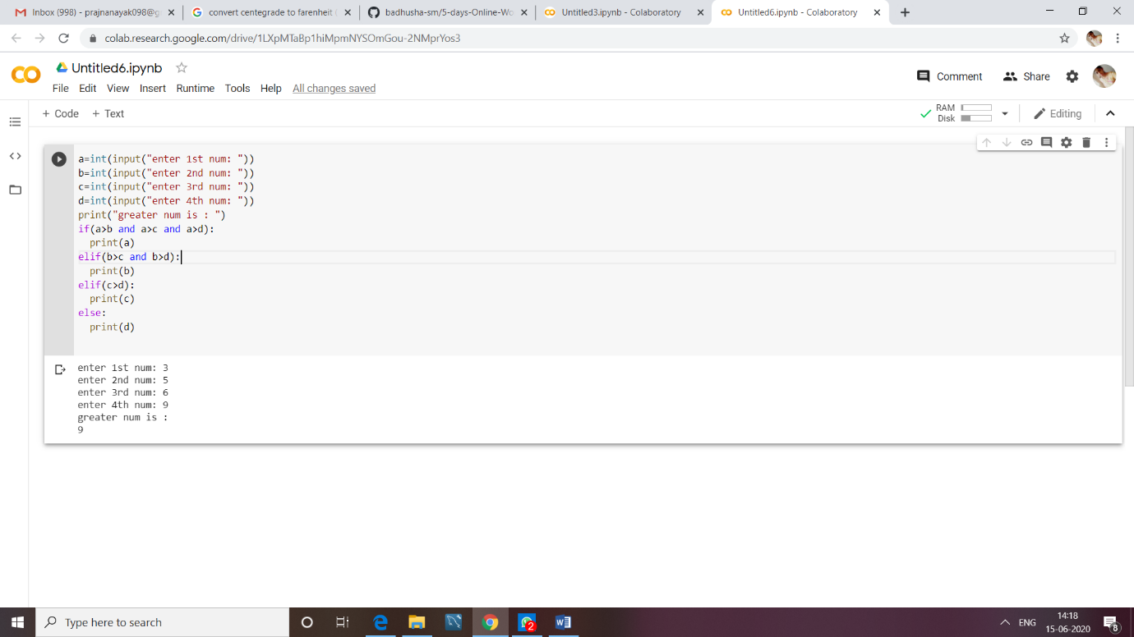

5.Write a menu program to perform the operations ( ODDorEven, Factorial, ODDNoUptoN, PrimeUptoN ) using functions for two nos with menu choice.

loop = 1

choice = 0

def oddoreven(a):

if(a%2==0):

print("even")

else:

print("odd")

def fact(num):

factorial=1

if num < 0:

Print("Sorry, factorial does not exist for negative numbers")

elif num == 0:

print("The factorial of 0 is 1")

else:

for i in range(1,num + 1):

factorial = factorial*i

print("The factorial of",num,"is",factorial)

def odd(n):

print("odd numbers: ");

for i in range(1,n+1):

if(i%2!=0):

print(i)

def prime(l,h):

print("prime numbers: ")

for num in range(l,h + 1):

if num > 1:

for i in range(2,num):

if (num % i) == 0:

break

else:

print(num)

while loop == 1:

print ("Welcome")

print ("your options are:")

print ("")

print("1) odd or even")

print("2) factorial")

print("3) odd upto n")

print("4) prime upto n")

print("5) Quit ")

print("")

try:

choice = int(input("Choose your option: "))

except:

print('please enter a valid number for option')

print("")

print("")

if choice == 1:

x = int(input(" Enter no: "))

oddoreven(x)

elif choice == 2:

x = int(input("Enter no: "))

fact(x)

elif choice == 3:

x = int(input("Enter range: "))

odd(x)

elif choice == 4:

x = int(input("Enter lower range: "))

y = int(input("Enter upper range: "))

prime(x,y)

elif choice == 5:

loop = 0

else:

print("please choice a valid option from 1 to 5")

choice=0

print ("Thank-you ")

